


Designing and Testing a Digital Front-End Block Using Verilog HDL
The Final Submission

Supervisor: Eng. Eslam Mahmoud
Team 6
Team members
Abdulrahman Saad Samhoud
Ahmed Ibrahim Hassan Ibrahim
Mahmoud Ismail Mahmoud Abdallah
Mohamed Ahmed Mohamed Elsayed
Moheb Mikhael Heshmat

Abbreviation:
Abbreviation | Description
IO | Input-Output
FD | Fractional Decimator
CIC | Cascaded Integrator-Comb
IIR | Infinite Impulse Response
FIR | Finite Impulse Response
LPF | Low Pass Filter
$$f_{o1}$$ | Interference at 1 MHz
$$f_{o2}$$ | Interference at 2.4 MHz
SNR | Signal to Noise Ratio
DUT | Design Under Test
AMBA | Advanced Microcontroller Bus Architecture
APB | Advanced Peripheral Bus

Table of Contents
Top Level DFE Overview: 6
System IO Table: 7
DFE IOs: 7
AMBA APB IOs: 7
Stage 1 - Fractional Decimator: 8
The Fractional Decimator Overview: 8
Low pass FIR filter: 8
Down sampling by 3: 8
1. Hardware Implementation 9
MUX Blocks: 9
2-bit Counter: 9
Multiplier Blocks: 9
Delay Chain: 9
Adder Block: 9
Output Selector: 9
Simulation Diagrams: 10
The Output Result: 10
SNR: 10
Stage 2 – Notch Filter: 11
The Notch Filter Overview: 11
The Filter Equation: 11
The Hardware Implementation: 11
1. The Frequency Response 13
Simulation Diagrams: 13
The Output Result: 13
SNR: 13
Stage 3 – Cascaded Integrator-Comb: 14
1. The CIC Filter Overview 14
2. The Hardware Implementation 14
Simulation Diagrams: 16
SNR 18
The System Wrapper: 19
Register File Content: 19
Registers Mapping: 19
Fixed Point converting: 19
Table of Accumulator Bits: 20
Waveforms output 21

Table of figures
Figure 1 - System block-level 4
Figure 2:System block-level 4
Figure 3:Fractional Decimator Operation 6
Figure 4 - Fractional Decimator Operation 6
Figure 5 - Up sampling by factor of 2 6
Figure 6 - Down sampling by factor of 3 6
Figure 7 - Transposed Polyphase Decimator 7
Figure 8 - Fractional Decimator Python model output 8
Figure 9 - IIR Notch Filter Block-Level 9
Figure 10 - Direct Form II implementation 9
Figure 11 - One stage Notch filter using Hardware 10
Figure 12 - Notch Filter Frequency Response 11
Figure 13 – Notch Filter Python Model Output 11
Figure 14 - CIC Block-level 12
Figure 15 - CIC Architecture 12
Figure 16:Fracional Decimator Waveform 19
Figure 17:IIR Waveform 19
Figure 18:CIC Waveform 19

Top Level DFE Overview:
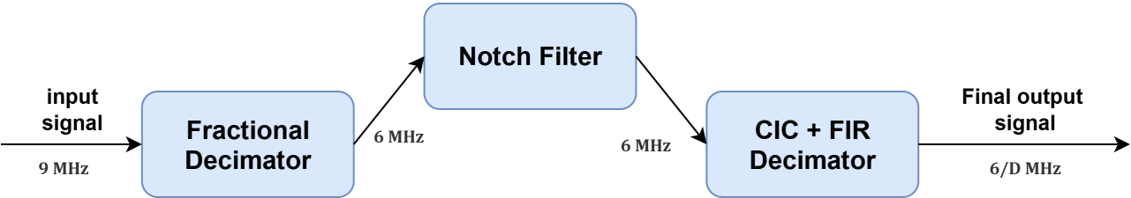
In modern digital communication and signal processing systems, the Digital Front-End (DFE) is responsible for preparing signals for further baseband processing. It typically performs sampling rate conversion, interference suppression, and spectral shaping.
Figure 1 - System block-level
Figure 2:System block-level
The system receives the input signal with $F_{s}=9 MHz$. The fractional decimator works on down sampling to $F_{s}=6 MHz$, and then the notch filter supresses unwanted narrowband interference. Finally the CIC decimator reduces the sampling rate from $F_{s}=6 MHz$ to a much lower rate $F_{s}=\frac{6}{D} MHz$.

System IO Table:

DFE IOs:
Signal name | Direction | Description
clk | Input | System clock
rst_n | Input | Asynchronous active-low reset
notch_enable | Input | Active-low bypassing for notch filter
cic_decimation_factor [4:0] | input | Average filter decimation factor
data_in [width-1 : 0] | input | Input data
data_out [width-1 : 0] | output | Output data

AMBA APB IOs:
Signal name | Direction | Description
PCLK | Input | System clock
PRESETn | Input | Asynchronous active-low reset
PSEL | Input | Select. The APB bridge unit generates this signal to each peripheral bus slave.
PENABLE | input | Enable. This signal indicates the second and subsequent cycles of an APB transfer.
PWRITE | input | Direction. This signal indicates an APB write access when HIGH and an APB read access when LOW
PADDER [ADDR_WIDTH-1 : 0] | output | Address. This is the APB address bus. It can be up to 32 bits wide and is driven  by the peripheral bus bridge unit.
PWDATA [DATA_WIDTH-1 : 0] |  | Write data. This bus is driven by the peripheral bus bridge unit during write  cycles when PWRITE is HIGH.
PRDATA [DATA_WIDTH-1 : 0] |  | Read Data. The selected slave drives this bus during read cycles when  PWRITE is LOW.
DFE Signals
input_data [DFE_WIDTH-1 : 0] |  | Input data of the DFE
output_data [DFE_WIDTH-1 : 0] |  | Output data of the DFE

Stage 1 - Fractional Decimator:
Convert the input signal, from $9 MHz$ ,to $6 MHz$ using fractional resampling. This is achieved using the L and M $\frac{L}{M}= \frac{2}{3}$).

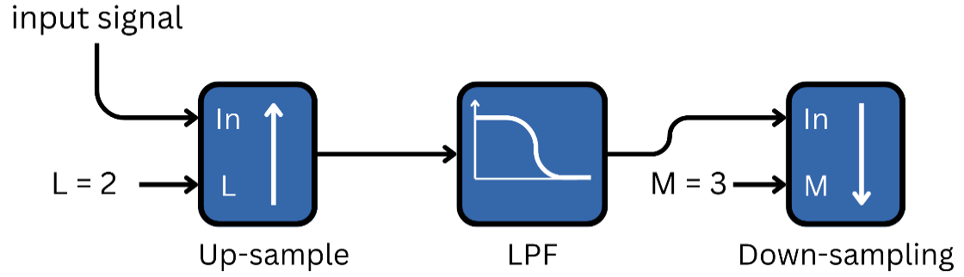
The Fractional Decimator Overview:
Figure 3:Fractional Decimator Operation
Figure 4 - Fractional Decimator Operation
First, the input signal will be up-sampled by a factor of 2 (Fs = 18 MHz) and then removed of imaging due to up-sampling using FIR filter, and finally it is decimated by a factor of 3 to reduce the sampling rate (Fs = 6 MHz).
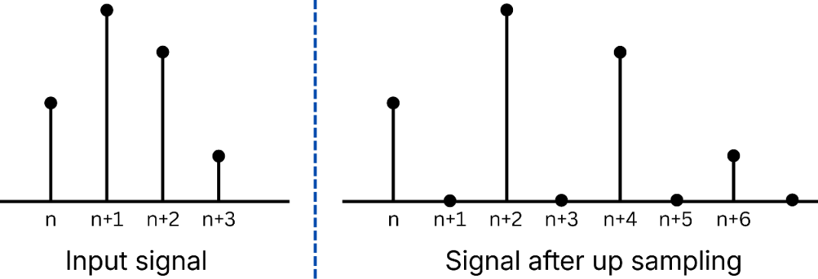
Upsampling by 2: increasing the sampling rate of a discrete-time signal, x[n], by a factor of L=2, utilizing zero insertion.

Figure 5 - Up sampling by factor of 2
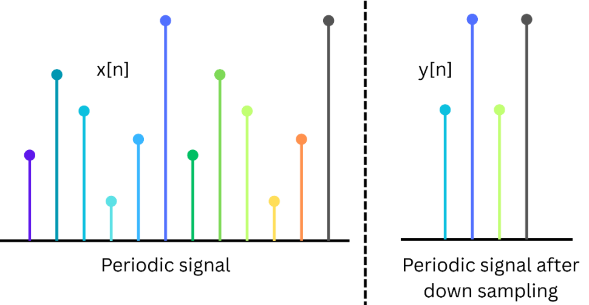
Low pass FIR filter: is used before decimation for preventing aliasing and defining the new signal bandwidth, which is $≈$ 3 MHz (new Nyquist).
Figure 6 - Down sampling by factor of 3
Down sampling by 3: reduces the sampling rate by keeping one out of every 3 samples: $y\left[n\right]=x[3n]$.
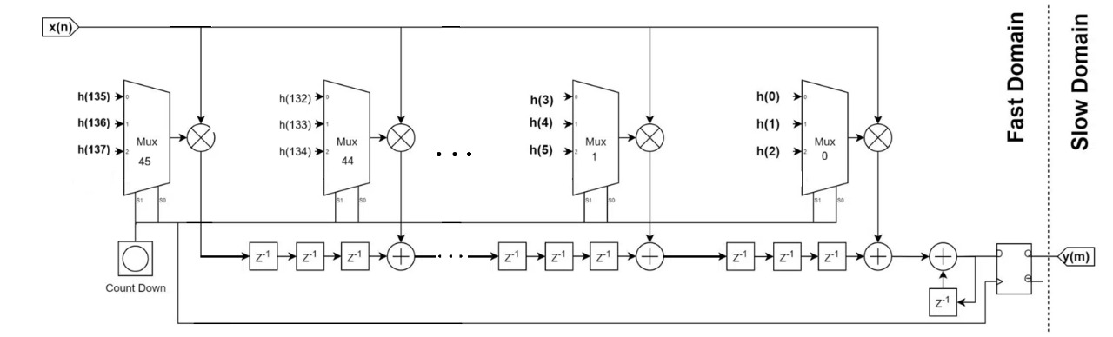
- Hardware Implementation:
Figure 7 - Transposed Polyphase Decimator
The architecture is based on a Transposed Polyphase Filter.
For decimation by 3, we split the filter into 3 polyphase branches:
$$E_{0}\left[n\right]=h\left[3n\right]$$
$$E_{1}\left[n\right]=h\left[3n+1\right]$$
$$E_{2}\left[n\right]=h[3n+2]$$
MUX Blocks: each MUX selects one tap from its polyphase group.
2-bit Counter: selects the correct coefficient for each cycle.
Multiplier Blocks: each MUX output is multiplied by the current input sample x(n).
Delay Chain: This delay structure stores partial FIR sums. In a transposed implementation, each register holds partial results for future outputs. The delay chain corresponds to tap delays, shared across cycles.
Adder Block: Each multiplier output is added to a stored partial sum. Over 3 cycles, each partial result accumulates all FIR contributions for one output sample. After the last cycle, the final output sample is complete.
Output Selector: The decimator outputs one sample every 3 cycles.
A modulo-3 counter enables output only when: cycle = 2 (end of polyphase accumulation). This sample is then labelled y(m).

Simulation Diagrams:

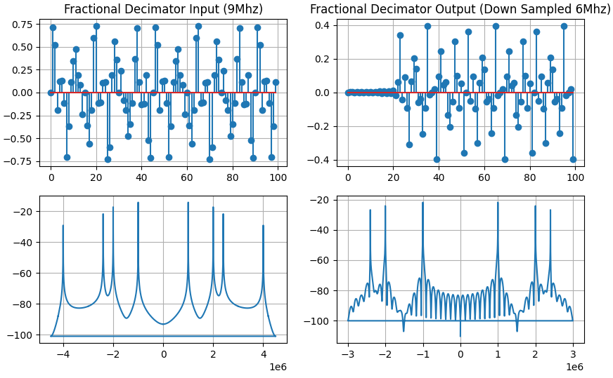
Output Results:
Figure 8 - Fractional Decimator Python model output
SNR: The fractional decimator shows moderate attenuation, which is expected due to normalized polyphase filter coefficients. The required accumulator width is small, indicating limited dynamic range growth. The SNR of 75.50 dB reflects excellent accuracy and very low quantization noise.

Stage 2 – Notch Filter:
Suppresses unwanted narrowband interferences at $5 MHz$ and $2.4 MHz$ relative to $6 MHz$ (after the first stage – fractional decimator). It’s resolved that the component of $5 MHz$ will be folded at $1 MHz$ due to aliasing and the filter can resolve frequencies up to $3 MHz$.

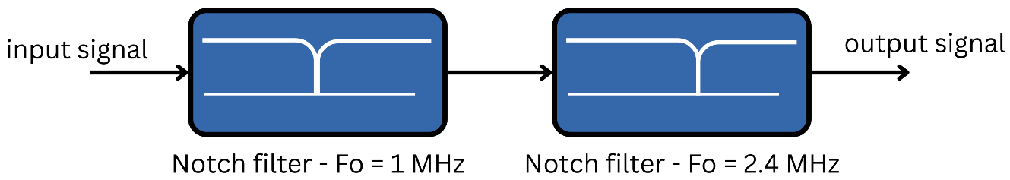
Notch Filter Overview:
Figure 9 - IIR Notch Filter Block-Level
The input signal passes through two stages notch filter to remove the interference.

Filter’s Equation:
$$H\left(z\right)= \frac{1-2r_{z}\cos\left(w_{o}\right)z^{-1}+ r_{z}^{2} z^{-2}}{1-2r_{p}\cos\left(w_{o}\right)z^{-1}+ r_{p}^{2} z^{-2}}$$
To achieve the BW $<50 KHz$ and notch depth$>50 dB$, zero radius must be a little less than 1, and the pole radius too, to achieve stability.

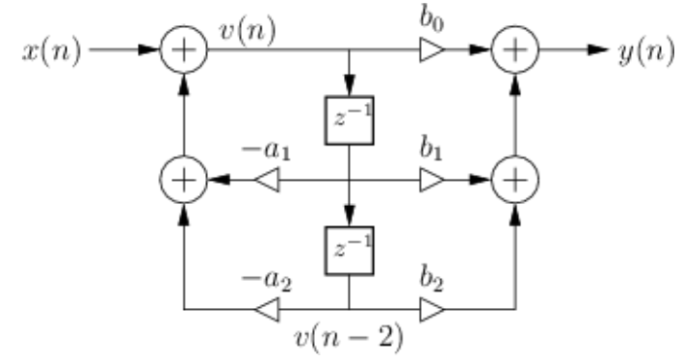
Hardware Implementation:
Figure 10 - Direct Form II implementation

The filter can be written as:
$$y\left[n\right]=B_{0} x\left[n\right]+ B_{1} x\left[n-1\right]+ B_{2} x\left[n-2\right]- A_{1} y\left[n-1\right]- A_{2} y[n-2$$
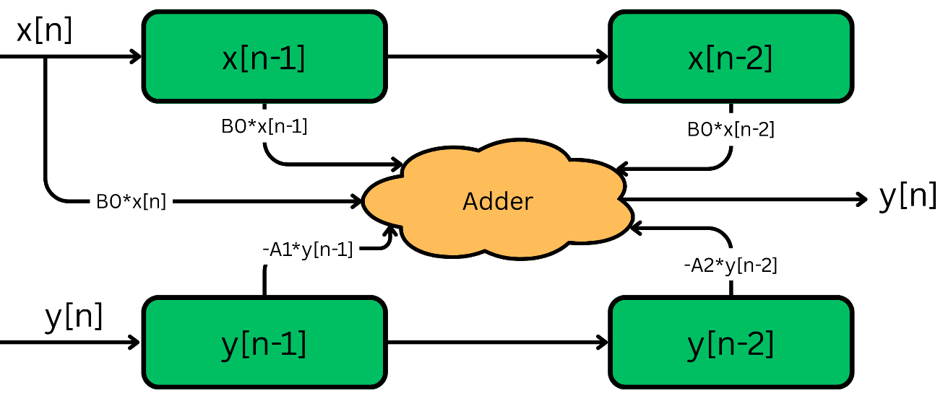
Notice that, the system is LTI with memory, so values need to be stored in register through the computation.
Figure 11 - One stage Notch filter using Hardware
Where $B_{0} , B_{1} , B_{2} , A_{1} , and A_{2}$ are the filter coefficients, computed using the Python model using S16.14 fixed point format.
Sign | Integer | Fraction
1-bit | 1-bit | 14-bit
With range [-1.999: 1.999].
Coefficient | Floating point value | Fixed point value
$$f_{o}=1 MHz$$
$$B_{0}$$ | 1 | 16’h4000
$$B_{1}$$ | -0.9999 | 16’hC000
$$B_{2}$$ | 0.9999 | 16’h4000
$$A_{1}$$ | -0.970 | 16’hC1EC
$$A_{2}$$ | 0.9409 | 16’h3C38
$$f_{o}=2.4 MHz$$
$$B_{0}$$ | 1 | 16’h4000
$$B_{1}$$ | 1.6180137633 | 16’h678E
$$B_{2}$$ | 0.999972 | 16’h4000
$$A_{1}$$ | 1.569492 | 16’h6473
$$A_{2}$$ | 0.9409 | 16’h3C38

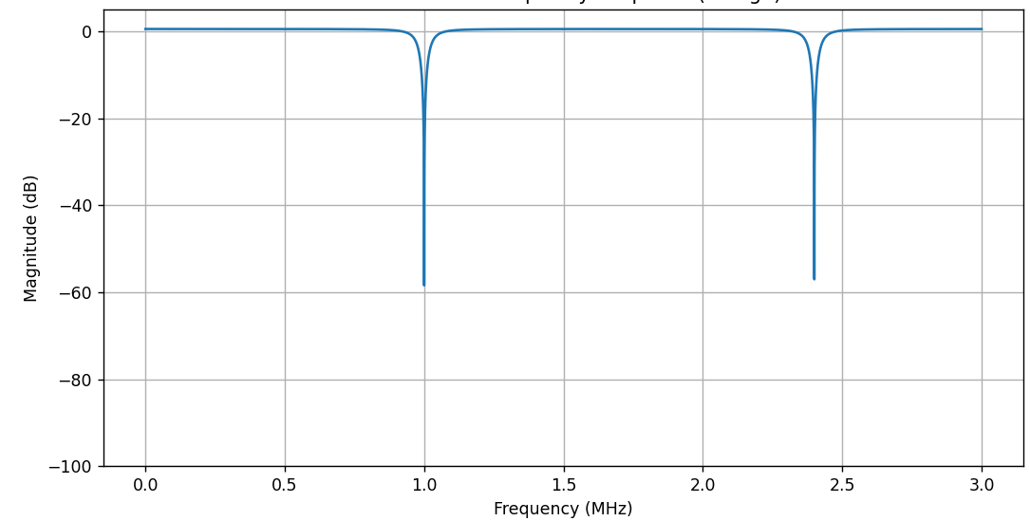
- The Frequency Response:
Figure 12 - Notch Filter Frequency Response
BW $≈58 Hz$.
The notch depth $>50 dB$.

Simulation Diagrams:

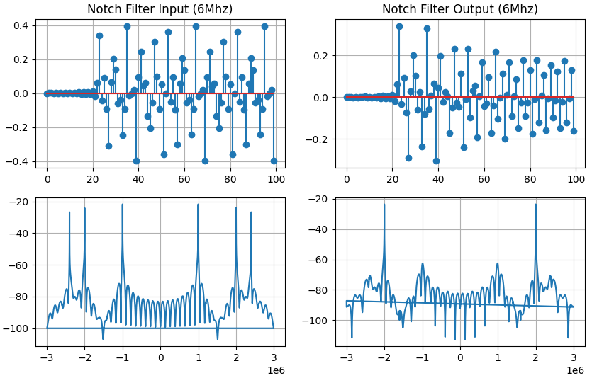
The Output Result:
Figure 13 – Notch Filter Python Model Output
SNR: The IIR stage introduces additional attenuation, reducing signal amplitude further. An 18-bit accumulator is sufficient, but the SNR drops to 58.80 dB, which is typical for fixed-point IIR filters due to feedback sensitivity and coefficient quantization.

Stage 3 – Cascaded Integrator-Comb:
The third stage of the Digital Front End (DFE) reduces the sample rate from 6 MHz to $\frac{6}{D} MHz$ using a Cascaded Integrator-Comb (CIC) decimator with a runtime-selectable decimation factor $D∈\{1, 2, 4, 8, 16\}$.Fu
nctionally, the CIC stage:
- Produces 1 output for every D input, so the output sample is down sampled.
- Minimizes hardware cost (multiplier-free decimation), with fixed latency.

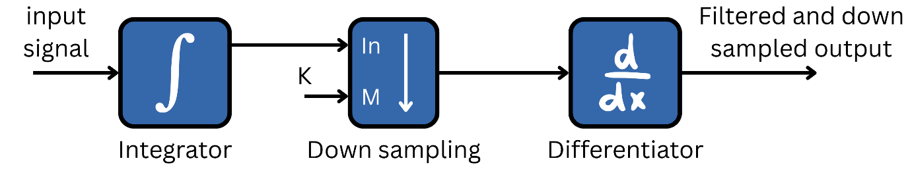
- The CIC Filter Overview:
Figure 14 - CIC Block-level
The single-stage CIC first integrates the input by adding the current sampled input and the delayed sampled input, then decimates according to the selected value, and lastly, it differentiates the last two samples.
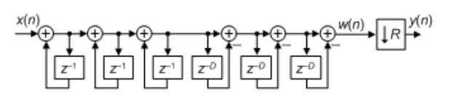
- The Hardware Implementation:
Figure 15 - CIC Architecture
Since we decimate the sampling frequency, aliasing must occur, but it is a trade-off between the number of stages and the droop that happens.
If we increase the number of stages, the filter becomes more anti-aliasing and image-rejection, but on the other side, the drooping happens that requires a compensation filter to equalize the drooping.
Thus, a sweet spot was chosen of 3 stages for the CIC filter, manipulating the position of the three integrators and differentiators, and leaving the down sampling at the end of the stage. This architecture is widely used.
Also, another thing to consider is that multiple stages give gain according to this equation:
$$Gain=D_{max}^{N}= {16}^{3}=4096$$
Where $D_{max}$ is the maximum decimated value, which is 16.
$N$ is the number of cascaded stages of CIC.
Thus, sizing of the output should be done by accounting for the gain:
$${Bit}_{growth}=ceil\left(N· \log_{2}\left(16\right)\right)=12 bits$$
Then the internal width of our register should be:
$$Width=16+12=28 bits$$

Simulation Diagrams:
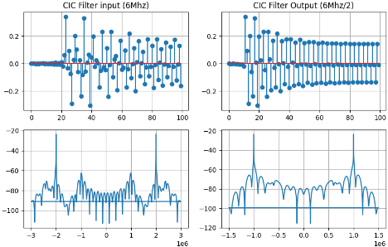
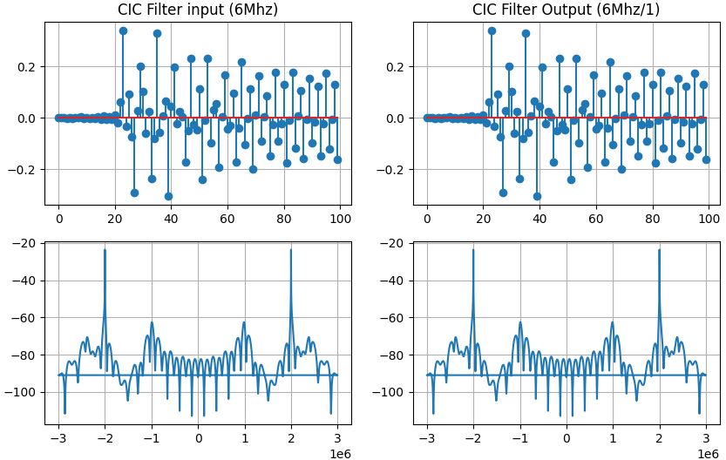
The Output Results:
Figure 15 - Output for D = 2
Figure 14 - Output for D = 1

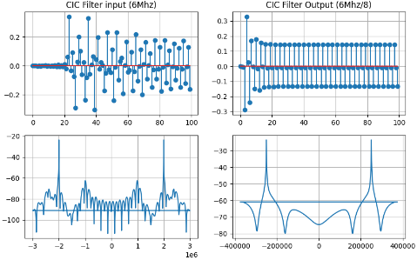
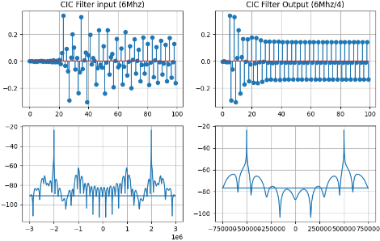
Figure 17 - Output for D = 8
Figure 16 - Output for D = 4

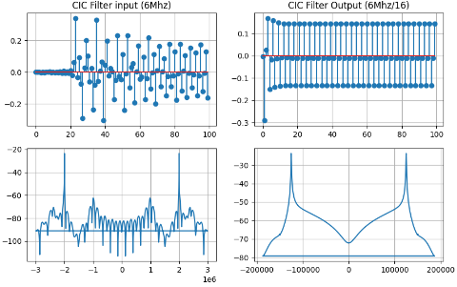
SNR: The CIC filter exhibits a gain close to what is expected from its cascade structure. The 30-bit accumulator is necessary to safely handle integrator growth without overflow. The SNR of 59.41 dB aligns with typical CIC behavior, where quantization noise and passband droop reduce accuracy compared to FIR-based stages.
Figure 18 - Output for D = 16

The System Wrapper:
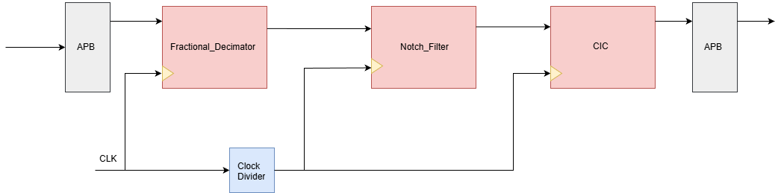
The system is wrapped with an APB interface to communicate with the microprocessor, and adjusting the system control signals or coefficients.
Figure 19 - The Whole System with APB Interface

Register File Content: eight registers with width size 32-bit.
Register | Content
R0 | Control signals
R1 | Status flags
R2 to R6 | Notch filter coefficients

R0 | Enable |  |  |  |  | Bypass |  |  |  | CIC factor |  |  | [12:3]
R0 | [0] | [1] | [2] | [3] | [4] | [5] | [6] | [7] | [8] | [9] | [10] | [11] | 1’d0
R0 | FD | F01 | F02 | CIC | clk_div | FD | F01 | F02 | CIC | Factor [2:0] |  |  | Not used

Registers Mapping:

Register | [0:17] | [18:31]
R2 | $$B_{0}_f_{01}$$ | $$B_{1}_f_{01}$$
R3 | $$B_{2}_f_{01}$$ | $$A_{1}_f_{01}$$
R4 | $$A_{2}_f_{01}$$ | $$B_{0}_f_{02}$$
R5 | $$B_{1}_f_{02}$$ | $$B_{2}_f_{02}$$
R6 | $$A_{1}_f_{02}$$ | $$A_{2}_f_{02}$$

Fixed Point converting:
The notch filter coefficient is represented by S16.14 (due to the coefficient range), and the data output from the fractional decimator is represented by S16.15. Between the fractional decimator and the notch filter, there is a S16.15 to S16.14 converter.

Table of Accumulator Bits:
STAGE | Accumulator Bits
Fractional Decimator | 18 bits
IIR filter | 18 bits
CIC | 30 bits

Waveforms output
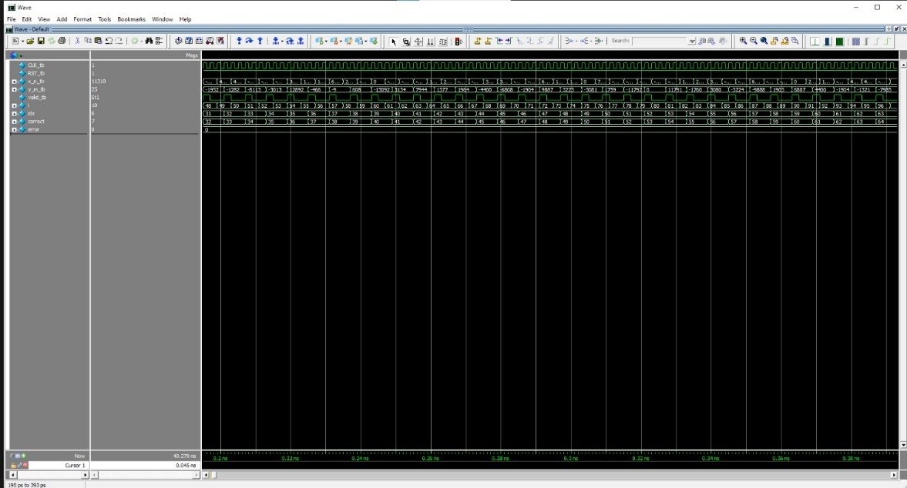

Figure 16:Fracional Decimator Waveform
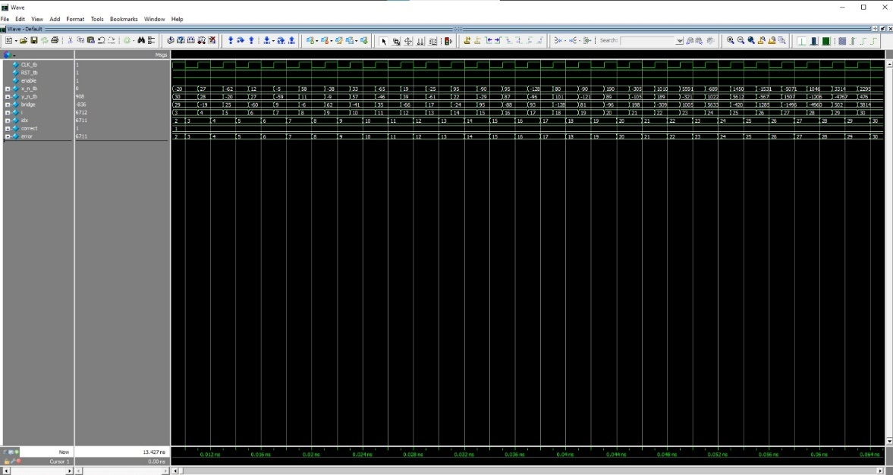

Figure 17:IIR Waveform
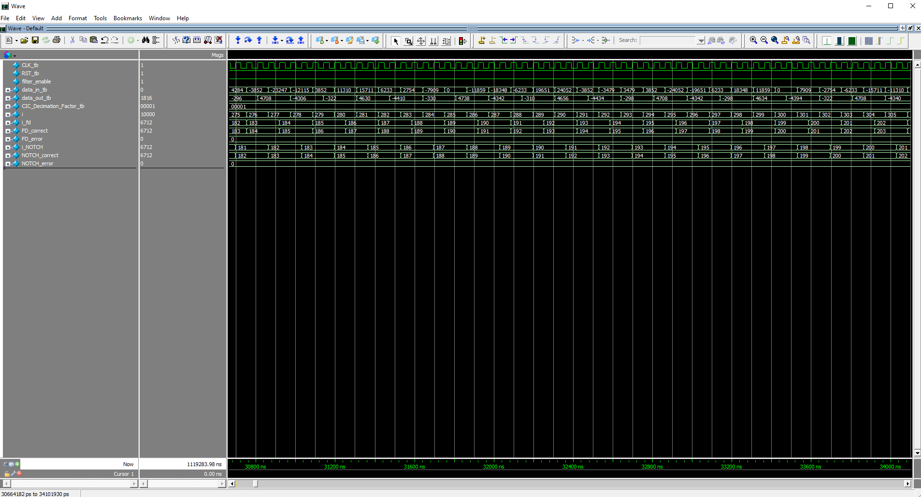
Figure 18:CIC Waveform

FPGA Flow:
Power consumption
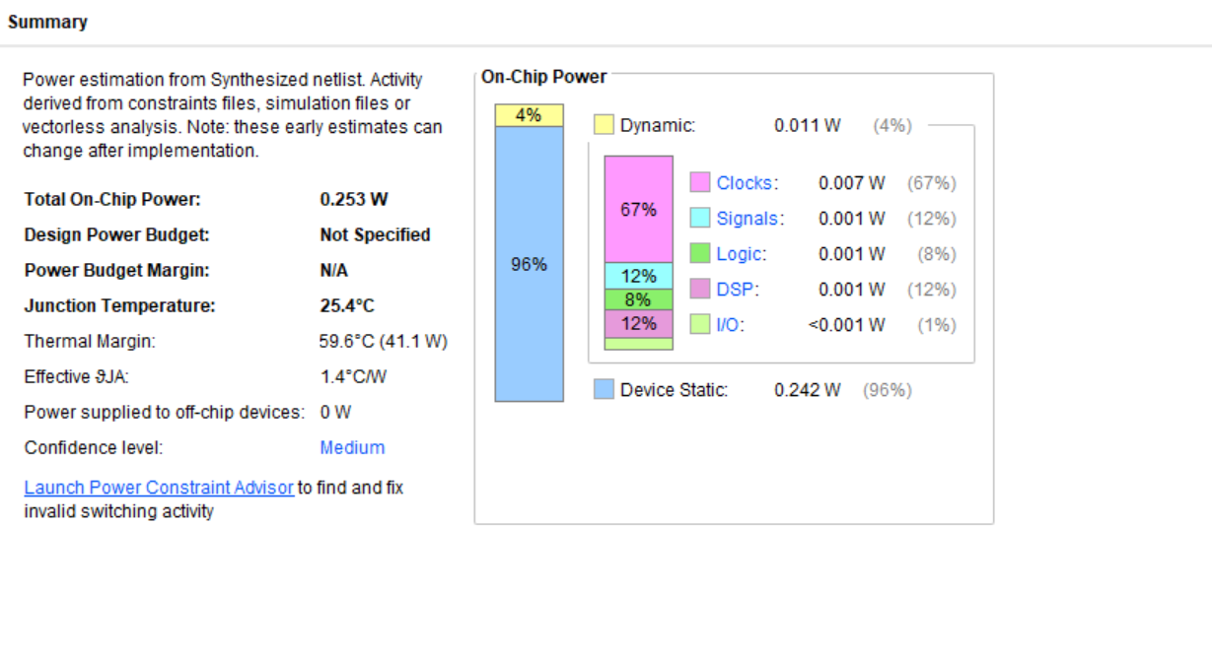
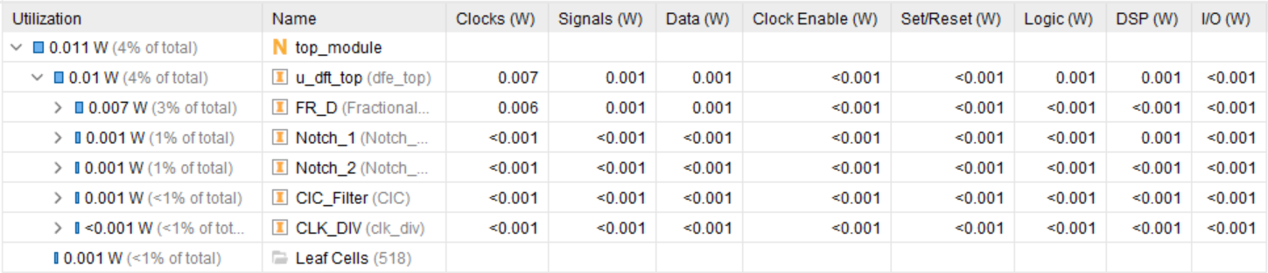

STA

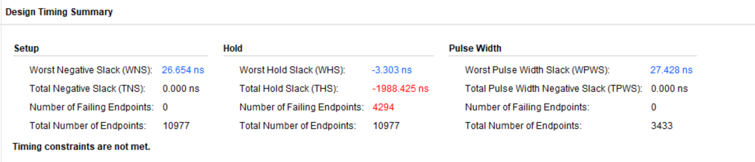
Source synced to the slowed clock

Resource Utilizaion
